Curriculum Overview for Year 3
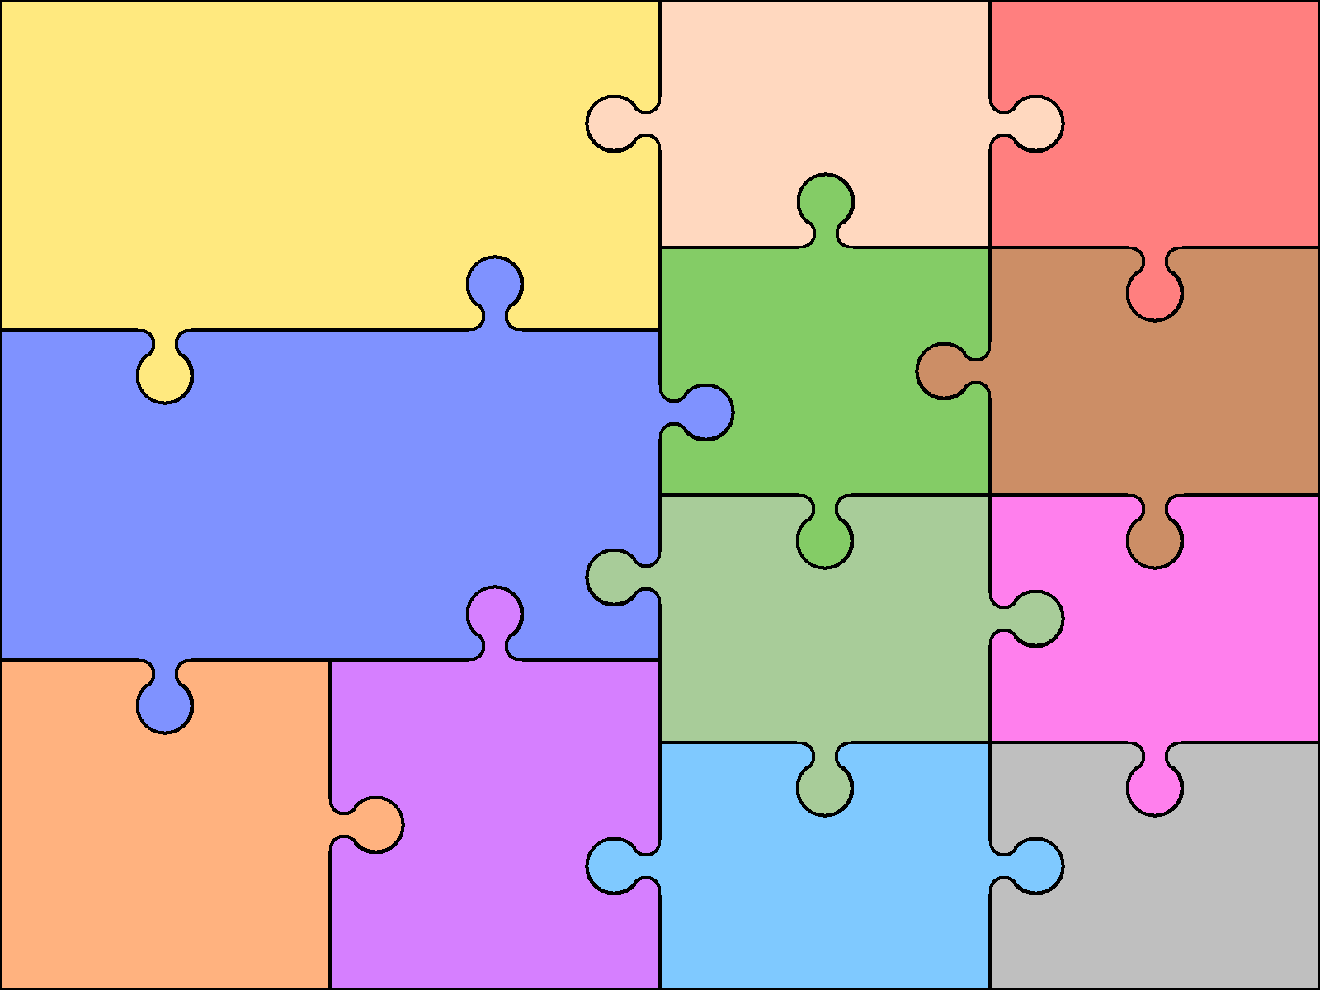  Reading  Use knowledge to read ‘exception’ words  Read range of fiction & non-fiction  Use dictionaries to check meaning  Prepare poems & plays to perform  Check own understanding of reading  Draw inferences & make predictions  Retrieve & record information from non-fiction books  Discuss reading with others | English  Writing  Use prefixes & suffixes in spelling  Use dictionary to confirm spellings  Write simple dictated sentences  Use handwriting joins appropriately  Plan to write based on familiar forms  Rehearse sentences orally for writing  Use varied rich vocabulary  Create simple settings & plot  Assess effectiveness of own and others’ writing |  | Grammar  Use range of conjunctions  Use perfect tense  Use range of nouns & pronouns  Use time connectives  Introduce speech punctuation  Know language of clauses  Speaking & Listening  Give structured descriptions  Participate activity in conversation  Consider & evaluate different  viewpoints | Art & Design  Portraits  Portraying Relationships  Pencil drawing  Changing Places  Pattern | Computing  E Safety  Bringing Images to Life  Coding  Research & creative skills  Internet research & presentation
 |  |  |  | Design & Technology  Lucious Lunches  Pencil Cases  Moving Monsters | Geography  UK  Europe  Mountains
Autumn  Place Value  Addition and Subtraction  Multiplication and Division | Mathematics  Spring  Multiplication and Division  Money  Statistics  Length and Perimeter  Fractions |  | Summer  Fractions  Time  Properties of shape  Mass and Capacity
 |  |  |  | Modern Languages  French – Greetings  Numbers  Days / Months  Classroom objects  Family  Pets  Colours | Music Charanga  Pulse / Pitch / Rhythm games  Singing  Group performance  Glockenspiel / Recorder  Listen & Appraising  Through songs such as Three Little Birds, The Dragon Song
Science  Skeletons & Muscles  Light  Forces and Magnets  Rocks & Soils  Plants  Nutrition |  | History  Stone Age  Bronze Age  Iron Age  Ancient Egypt
 |  |  |  | Physical Education  Hockey Table Tennis  Yoga Athletics  Netball Tennis  Dance Rounders  Gym Tag Rugby | Religious Education  Religious Festivals  Religious symbols  Islam – Beliefs and Practices  Christianity - Key Figures & Stories  Special Places of worship

