Date
Can I use adverbials of time?
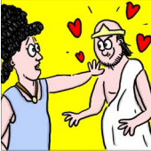
King Polydectes fell in love with Danae but she didn’t want to marry him. | King Polydectes decided to get rid of Perseus. He told Perseus to bring back the head of Medusa. | Perseus didn’t know where to look for Medusa and the Gorgons. He called on the gods for help. | Athena gave Perseus some magical objects to help him. | Perseus stole the Graeae’s magical eye. He wouldn’t give it back to them until they told him where to find the Gorgons.
 |  |  |  | 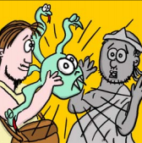
Perseus flew to the island where the Gorgons lived. | He used the shield as a mirror and chopped off the head of Medusa. He put the head inside the satchel. | Perseus escaped by putting on the helmet of Hades which made him invisible. | Perseus arrived back home just as King Polydectes was about to marry Danae. | Perseus showed him the Gorgon’ head and Polydectes was instantly turned to stone. Danae was saved!
Date
Can I use adverbials of time?

