Curriculum Overview for Rowan, Cherry & Chestnut B 2020
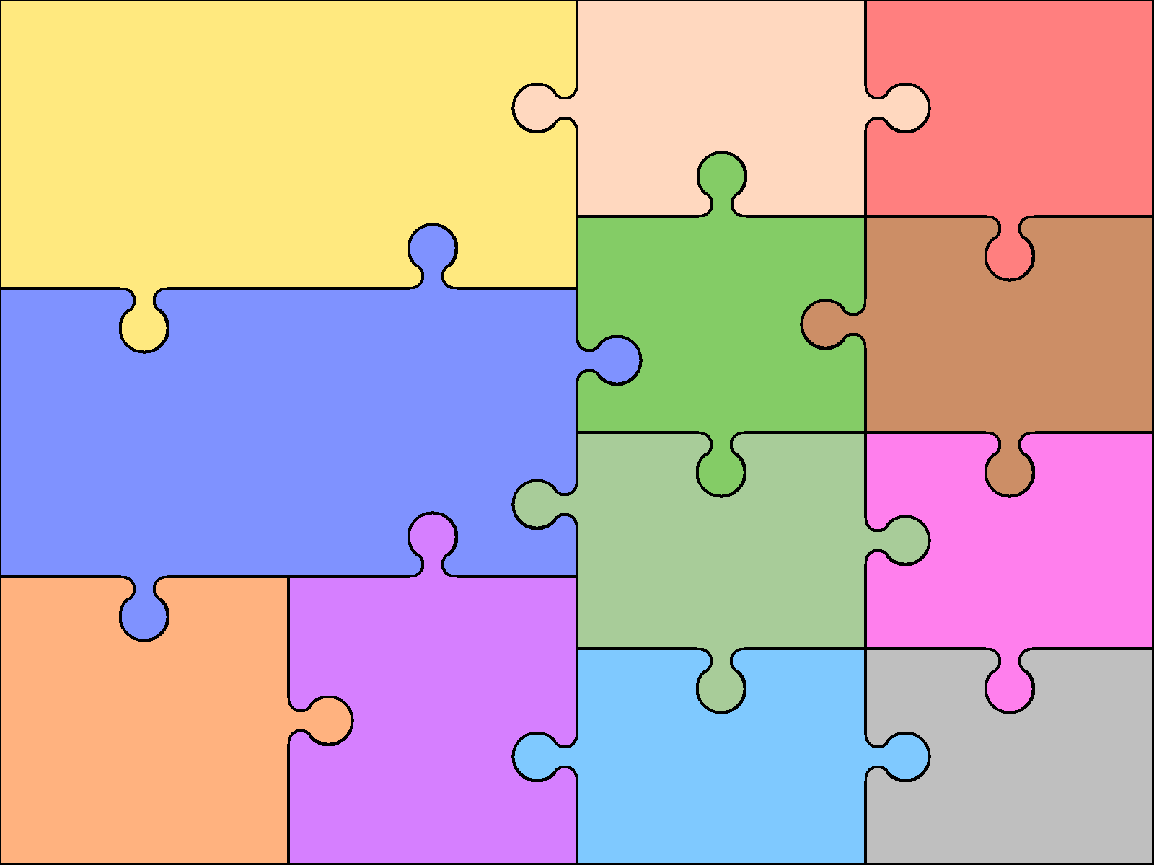  English  Reading  Read a broad range of genres  Recommend books to others  Make comparisons within/across books  Support inferences with evidence  Summarising key points from texts  Identify how language, structure, etc. contribute to meaning  Discuss use of language, inc. figurative  Discuss & explain reading, providing reasoned justifications for views | Writing  Use knowledge of morphology & etymology in spelling  Develop legible personal handwriting style  Plan writing to suit audience & purpose; use models of writing  Develop character & setting in narrative  Select grammar & vocabulary for effect  Use a wide range of cohesive devices  Ensure grammatical consistency |  | Grammar  Use appropriate register/ style  Use the passive voice for purpose  Use features to convey & clarify meaning  Use full punctuation  Use language of subject/object  Speaking & Listening  Use questions to build knowledge  Articulate arguments & opinions  Use spoken language to speculate,  hypothesise & explore  Use appropriate  register & language | Art  William Morris  A Sense of Watercolour  Art of Africa | Computing  Online safety  Coding  Spreadsheets  Databases  Game creator  3D modelling  Concept maps  Word processing
 |  |  |  | Design & Technology  Christmas tree decorations  Faberge eggs  Afternoon tea | Geography  North & South America  Rivers & the Water Cycle  Local River Walk
Number/Calculation  Secure place value & rounding to 10,000,000, including negatives  All written methods, including long division  Use order of operations (not indices)  Identify factors, multiples & primes  Solve multi-step number problems  Algebra  Introduce simple use of unknowns | Mathematics  Geometry & Measures  Confidently use a range of measures & conversions  Calculate area of triangles / parallelograms  Use area & volume formulas  Classify shapes by properties  Know and use angle rules  Translate & reflect shapes, using all four quadrants  Data  Use pie charts  Calculate mean averages |  | Fractions, decimals & percentages  Compare & simplify fractions  Use equivalents to add fractions  Multiply simple fractions  Divide fractions by whole numbers  Solve problems using decimals & percentages  Use written division up to 2dp  Introduce ratio &  proportion
 |  |  |  | Modern Languages  Revision of personal identification  The Solar System  Hobbies  At the Restaurant  At the Cinema  At the Theme Park | Music  Glockenspiels  Five Gold rings  Classroom Jazz  Dancing in the street  Ukulele
Science  Animals inc. humans (circulatory system)  Living things and their habitats (lifecycles)  Properties of Materials  Forces  Evolution & Inheritance  Earth and space |  | History  Tudor Britain  The kingdom of Benin  Local History Study  Hitchin Walk
 |  |  |  | Physical Education  Dance - Fireworks  Lacrosse / Basketball  Outdoor & Adventurous  Cricket / Multi – Sports  Rounders / Tennis  Athletics | Religious Education  Creation stories  Justice and freedom  Humanism  Forgiveness

