What happened to Mr Stink to make him become homeless?

Chloe was the kind of girl who loved being alone with her thoughts. Often she would sit on her bed and make up stories about Mr Stink. Sitting on her own in her room, she would come up with all kinds of fantastical tales. Maybe Mr Stink was a heroic old sailor who had won dozens of medals for bravery, but had found it impossible to adapt to life on dry land? Or perhaps he was a world-famous opera singer who one night, upon hitting the top note in an aria at the Royal Opera House in London, lost his voice and could never sing again? Or maybe he was really a Russian secret agent who had put on an elaborate tramp disguise to spy on the people of the town?

Chloe didn’t know anything about Mr Stink. But what she did know, on that day when she stopped to talk to him for the first time, was that he looked like he needed the five-pound note she was holding much more than she did.

He seemed lonely too, not just alone, but lonely in his soul. That made Chloe sad. She knew full well what it was like to feel lonely.

Monday Week 1 Spoken Language 1

Profile of Raj

Use these headings to prompt thoughts about Raj’s character.

Appearance

His shop

Character

Raj as a shop-keeper

nice or nasty
kind or mean
chatty or silent
cheerful or morose
strict or relaxed

Tuesday Week 1 Composition 3
Grammar Teaching
This is background information for teachers and other adults. It is not intended for use with children.

Pronouns

Definition: A pronoun replaces a noun – that is a name.
Sometimes this is a proper noun, as in the name of a specific person, creature or place, e.g. ‘Joanna’ or ‘Mog’ (the cat) or ‘France’.
Sometimes this is a common noun such as ‘table’, ‘lion’ or ‘village’.

There are three types of pronoun

1. Personal pronouns  These refer to the missing name of a person, creature, place or thing.  Simon shouted to his mother.  He shouted to her.  Peter loves Basanti.  I love you.  Hobbes the dog loved to chase cats.  He loved to chase cats.  Lions like to sleep after eating their prey.  They like to sleep after eating it.  The kitchen is a light, airy room.  It is a light, airy room.  The journey is a long journey.  It is a long journey. | 2. Possessives  These refer to the possession of someone or something by someone or something.  Pronouns  These replace a noun.  All the old wooden windows are Anna’s.  All the old wooden windows are hers.  Mary, the baby, is Sunil’s.  The baby is his.  Determiners  These describe a noun.  The cat has her pride.  The blackbirds ate their worms slowly.  The bakery’s customers were few but loyal.  Its customers were few but loyal. | 3. Relative pronouns  These usually introduce a clause which gives us more information about a person, creature, place or thing.  The book, which was unopened, lay on the windowsill.  (‘which’ is a relative pronoun referring to the book)  Ann, who hated spiders, climbed onto a chair.  (‘who’ - relative pronoun referring to Ann)  Goa is a place in India that many people like to visit.  (‘that ‘ - relative pronoun referring to Goa)  The house, where he lived, is falling down. (‘where’ -relative pronoun refers to house)
Week 1 Wednesday Grammar 1

Two types of pronoun and determiners

Pronouns ‘stand in’ for nouns. Determiners qualify or describe nouns.
(Remember that ‘nouns’ are names of people, things, places or creatures.)

Mr Stink said that he was happy with Chloe’s shed. It seemed like a good home for him and the Duchess. The bag was his and Chloe held it in her hand.

Pronouns are used to stop us repeating ourselves. NB ‘her’ is a determiner.

We can spot two types of pronoun.

Personal pronouns  These refer to the missing name of a person, creature, place or thing.  Chloe shouted at her mother.  She shouted at her.  Mr Stink loves the Duchess.  I love you.  Elizabeth the cat loved to chase dogs.  She loved to chase them.  Wanderers like to sleep after eating some food.  They like to sleep after eating it.  The shed is a dark, dusty space.  It is a dark, dusty space.  The journey is a long journey.  It is a long journey. | Possessives – pronouns or determiners  These refer to the possession of someone or something by someone or something.  Possessive determiners  Annabelle is Mrs Crumb’s baby.  She is her baby.  Elizabeth the cat has her pride.  Both children ate their sausages slowly.  Possessive pronouns  All the old rock-band CDs are Dad’s.  All the old rock-band CDs are his.  (the CDs belong to Dad)  Those loyal customers are the newsagents’.  Those loyal customers are its.  (the customers belong to the newsagent)

WATCH OUT!
Pronouns replace the noun Determiners go beside the noun

Wednesday Week 1 Grammar 1

Identifying pronouns

Read this section of Mr Stink
Underline the personal pronouns in red.

Chloe studied the picture on the CD for a moment. Superimposed in front of a drawing of a giant snake stood four long-haired, leather-jacketed types. Chloe’s eyes fixed on the guitar player, who looked an awful lot like her dad, only with a mass of curly black hair.
“I don’t believe it!” said Chloe. “That’s my dad!”
She hadn’t any idea her dad had ever had a perm, let alone that he had been in a rock-band! She didn’t know which was more shocking – the idea of him not being bald, or the idea of him playing electric guitar.
“Really?” said Mr Stink.
“I think so,” said Chloe, holding the CD closer. “It looks like him anyway.” She was still studying it with a curious mixture of pride and embarrassment.
“Well we all have secrets, Miss Chloe. Now what shall I do if I require a pot of tea or a round of sausage sandwiches on white bread please with HP sauce on the side?” Is there a bell I should ring?”
Chloe looked at his shadowy face, a little surprised. She hadn’t realised that she was going to have to feed him as well as shelter him.
“No, there’s no bell,” she said. “Erm, you see that window up there? That’s my bedroom. That window is mine.”
“Ah, yes?”
“Well, if you need something, why don’t you flash this old bicycle light up at it? Then I can come down, and … erm … take your order.”
“Perfection!” exclaimed Mr Stink.
The Duchess lay sleeping on her bed, with its curled hose round her. The gentle snores they could hear were hers!

Re-read this section of Mr Stink
Underline the possessive pronouns in blue and the determiners in yellow.

Wednesday Week 1 Grammar 1

Replacing pronouns and possessive determiners – 1

Mr Stink took the photo from his pocket and placed it carefully on the shelf. He moved a box of Dad’s CDs and, as he did so, a couple fell out of it. Their covers were faded but he could see the picture Chloe had studied. Her Dad was clearly in it, playing guitar.

Final result
Mr Stink took the photo from Mr Stink’s pocket and placed the photo carefully on the shelf. Mr Stink moved a box of Dad’s CDs and, as Mr Stink did so, a couple fell out of the box. The CDs’ covers were faded but Mr Stink could see the picture Chloe had studied. Chloe’s Dad was clearly in the picture, playing guitar.

Possessive Apostrophes
Chloe’s CD apostrophe goes before the ‘s’ (only one Chloe)
The girl’s CD apostrophe goes before the ‘s’ (only one girl)
The CDs’ covers apostrophe goes after the ‘s’ (lots of CDs)
Dogs’ lives are shorter than ours. apostrophe after the ‘s’
Dogs have shorter lives than we do. NO apostrophe (plural)

Thursday Week 1 Grammar 2

Replacing pronouns – 2

Read this section of Mr Stink
Re-write it, changing every pronoun or possessive determiner into the name it replaces. All except THREE are in blue – find the missing three!
Be careful to include possessive apostrophes if you need them.

“Who on earth is he?” enquired Mr Stone as Mr Stink trudged around in his filthy pyjamas to the back door and opened it with a bang.
Chloe stared. “Oh, he’s the tramp who lives in our shed!” she said.
“I told you she was hiding something in it!” Annabelle exclaimed.
“He wasn’t there when I looked,” protested Dad, shaking his head. “He must have concealed himself behind an old trowel.”
“Is the shed yours or his?” asked Mr Stone curiously.

Now write a paragraph of your own which used exactly ten pronouns!

Thursday Week 1 Grammar 2

Dialogue layout and punctuation

“Are you wearing make up, Sir Declan?” enquired Mr Stink innocently.
“A little, yes. For the lights of course.” replied Sir David, a little taken aback by the question.
“Of course,” agreed Mr Stink. “Foundation?”
“Yes.” The presenter was trying to move on now.
“Eye liner?” Mr Stink was not to be side-tracked.
“A little.”
“Lip Gloss?” asked Mr Stink, still very interested.
“A smidge.” Sir David was getting a little flustered now.
“Looks nice. I wish I had some now. Blusher?”
The audience was chuckling throughout this exchange. Sir David moved on rapidly.
Notice
- A new line for each piece of speech, even when it is very short!
- Inverted commas ‘hugging’ what is said.
- ‘said’ or ‘replied’ or ‘asked’ do not normally have a capital letter even if the sentence being spoken is complete.
- Question marks, full stops and exclamation marks are used as appropriate within the speech marks.
- Commas are used if more speech is to come – see fourth line.
Monday week 2 Grammar 3

Missing punctuation in dialogue

Copy this extract but add the correct dialogue punctuation and layout.

I didn’t get a chance to go to the little boy’s room said Mr Stink. Of course, do go said Sir David angrily if you must then go. Thank you so much answered Mr Stink I shouldn’t be too long, I think it’s just a number one. My apologies exclaimed Mr Stink, crossing the stage again, I’m told the toilet is this way…!

Missing punctuation in dialogue

Copy this extract but add the correct dialogue punctuation and layout.

So Mrs Crumb, is it true… It’s Crooooome interrupted Mrs Crumb. Oh said Sir David I do apologise. We checked the pronunciation with your husband and he said it was ‘Crumb’. Mother went red with embarrassment, Sir David returned to his question. We want to discuss the difficult topic of homelessness he began solemnly but he was disrupted by Mr Stink may I just pop to the lavatory, Sir Duncan? The audience laughed loudly If you must Sir David was not impressed I forgot to go before I came Mr Stink explained.
Monday week 2 Grammar 3

A Story planner
- Story Start – becoming a wanderer
____________________________________________________________________________________________________________________________________________________________________________________________________________________________________________________________________________________________________________________________________________________________________________________________________________________________________________________________________________________________________________________________________________________________________________________________________________________________________________________________________________________
- Meeting a friend
____________________________________________________________________________________________________________________________________________________________________________________________________________________________________________________________________________________________________________________________________________________________________________________________________________________________________________________________________________________________________________________________________________________________________________________________________________________________________________________________________________________

- Resolution
____________________________________________________________________________________________________________________________________________________________________________________________________________________________________________________________________________________________________________________________________________________________________________________________________________________________________________________________________________________________________________________________________________________________________________________________________________________________________________________________________________________
_______________________________________________________

- Crisis
____________________________________________________________________________________________________________________________________________________________________________________________________________________________________________________________________________________________________________________________________________________________________________________________________________________________________________________________________________________________________________________________________________________________________________________________________________________________________________________________________________________
_______________________________________________________

Wednesday week 2 Composition 4

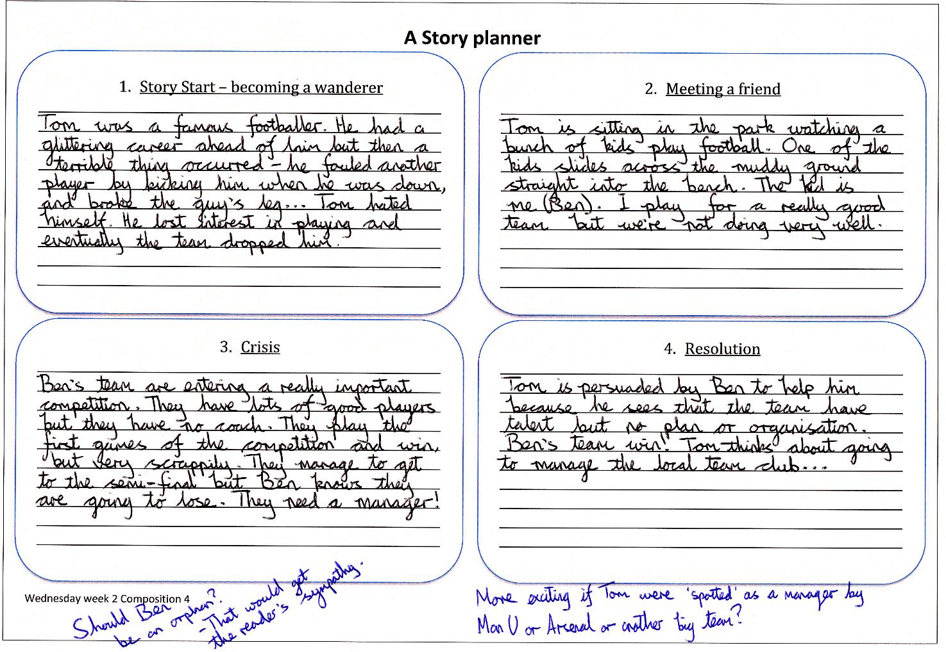
Thursday Week 2 Composistion

Improvements prompt sheet

Re-read your writing, sentence by sentence.
Check the following:

- Extending your sentences. Are your sentences really short? Can you add a clause – e.g. Tom trudged down the winding road, where a deep shade was provided by the trees on either side. Use conjunctions (joining words) to add description:
although
where
when
because

- Do you need to add some adjectives, adverbs or comparisons to your writing? So:
  - ‘the man’ could become ‘the slightly nervous young man…’
  - ‘ran’ could become ‘ran like a hare’ or ‘ran painfully..’

- Do you need to add some fronted adverbials at the start of any of your sentences? So think along these lines:
  - ‘With his heart in his mouth, the nervous young man ran painfully along the road.’
  - ‘As the moon rose, Tom wandered down the road.’

- Do you need to look at your use of pronouns? Are you repeating names? Remember you can use pronouns for things as well as people! So:
- ’Sam decided to let Miss Pom sleep in the bike shed. The shed was quite tattered, but…’ could be ‘Sam decided to let her sleep in the bike shed. It was quite tattered, but…’

- Final check – as you re-write and copy from your draft: check spellings, asking someone or using a dictionary if necessary. Also make sure your handwriting is clear and legible. Leave spaces between words and join letters needing to be joined.

Friday Week 2 Composition 7, Transcription 4 and Grammar 6

Chapter 2 Billionaire Boy

How could Joe tell that the other kids at his school were really posh? Suggest three ways.

What was the main reason that Joe wanted to go to the local comprehensive school?

What does Joe remember doing with his dad before they got rich?

What does Joe’s dad leave in the fridge for Joe’s birthday supper?

What do you think of Joe’s life so far? Would you like to be him?

Monday Week 3 Comprehension 3

Chapter 2 Billionaire Boy

How could Joe tell that the other kids at his school were really posh? Suggest two ways.

What does Joe really want for a birthday present?

What does Joe want to do on his birthday evening?

What does Joe’s dad leave in the fridge for Joe’s birthday supper?

What do you think of Joe’s life so far? Would you like to be him?

Monday Week 3 Comprehension 3

Joe’s School Timetable

Monday | Tuesday | Wednesday | Thursday | Friday
Latin | Ancient Greek | Fox hunting | Antique furniture appreciation hour | Medieval poetry reading
Straw Hat wearing | Croquet | Flower arranging | Range Rover tyre changing class | History of wearing corduroy
Play time
Royal studies | Pheasant shooting | Conversing about the weather | Discussion of whose daddy is the richest | Topiary class
The study of etiquette | Being beastly to servant class | History of cricket | Competition: who is best friends with Prince Harry? | Classical sculpture appreciation class
Show-jumping | Mandolin level 3 | History of the brogue | Learning to talk posh | Sporting in the party pages of The Tatler
Lunch time
Ballroom dancing | History of tweed | Playing Stately Home Top Trumps | Rowing club | Duck hunting
Debating society | Nose in the air hour | Reading Harper’s Bazaar | Debating society | Billiards
Scone eating | Learning to step over homeless person as you leave the opera | Ballet appreciation class | Chess | Classical music appreciation afternoon
Bow-tie tying |  | Top-hat polishing | The study of coats of arms
End of school – start of after school clubs (compulsory)
Punting and Polo | Finding your way out of a maze | Fencing with swords | Lecture: How to talk loudly in restaurants | Dinner party discussion topic class
Tuesday Week 3 Composition 7
Timetable for ________________________________________ school

Monday | Tuesday | Wednesday | Thursday | Friday
Tuesday Week 3 Composition 7

Menus for Joe’s school

Monday  Soup – Wasp  Gerbils on toast  OR  Hair lasagna (vegetarian option)  OR  Brick cutlet  All served with deep fried cardboard  Dessert – slice of sweat cake |  | Tuesday  Soup – Caterpillar consommé  Macaroni snot (vegetarian option)  OR  Road-kill bake  OR  Slipper frittata  All served with spider’s web salad  Dessert – Toenail ice cream
Wednesday  Soup – Cream of hedgehog  Parrot kedgeree (may contain nuts)  OR  Dandruff risotto  OR  Bread sandwich  OR  Soil bolognaise  All served with either boiled wood or deep fried iron filings  Dessert – Squirrel-dropping tart |  | Thursday – Indian day  Soup – Turban  Paper poppadoms (A4 or A3 sizes) with chutney  THEN  Wet-wipe tandoori (vegan option)  OR  Moth Korma (spicy)  OR  Newt vindaloo (very spicy)  All served with bogey bhajis  Dessert – Refreshing sand sorbet
Friday

Soup – Terrapin
Pan-fried otter steaks
OR
Owl quiche (kosher)
OR
Boiled poodle
All served with a slice of gravy

Dessert – Mouse mousse

Possessive apostrophes in menu items 1

Below is a list of truly DISGUSTING menu items!

Re-write each item using possessive apostrophes with the apostrophe in the correct place. The first one is done for you.

Snot of children = Children’s snot

Spit of teachers = ________________________

Tails of mice = ________________________

Poo of sheep = ________________________

Stink of foxes = ________________________

Hair of the dog = ________________________

Mess of geese = ________________________

Fur of the cat = ________________________

Tears of the baby = ________________________

Wee of worms = ________________________

Sting of bees = ________________________

Ears of cattle = ________________________

Bodies of lice = ________________________

Wednesday Week 3 Grammar 6

Possessive apostrophes in menu items 2

Below is a list of truly DISGUSTING menu items!

Re-write each item using possessive apostrophes with the apostrophe in the correct place. The first one is done for you.

Snot of children = Children’s snot

Spit of teachers = ________________________

Tails of mice = ________________________

Poo of sheep = ________________________

Hair of the dog = ________________________

Fur of the cat = ________________________

Wee of worms = ________________________

Sting of bees = ________________________

Bodies of lice = ________________________

Wednesday Week 3 Grammar 6

Teachers’ Catchphrases

At number 10 – “Walk, don’t run!”
A non-mover at 9 – “Are you chewing?”
Up three places to 8 – “I can still hear talking.”
A former no. 1 now at 7 – “It doesn’t need discussion.”
A new entry at 6 – “How many times do you need to be
told?”
Down one place to 5 – “Watch your spelling!”
Another non-mover at 4 – “I will not tolerate litter!”
New at 3 – “Do you want to pass your GCSEs?”
Just missing the top spot at 2 – “Would you do that at
home?”
And still at number 1 – “It’s not just yourself you’ve let down, it’s the whole school.”

Thursday Week 3 Grammar 7

Teachers’ Catchphrases – Types of sentence

- “Walk, don’t run!” = command
- “Are you chewing?” = question
- “I can still hear talking.” = statement
- “It doesn’t need discussion.” = statement
- “How many times do you need to be told?” =
question
- “Spelling!” = exclamation
- “I will not tolerate litter!” = exclamation
- “Do you want to pass your GCSEs?” = question
- “Would you do that at home?” = question
- “It’s not just yourself you’ve let down, it’s the whole school.” = statement
Thursday Week 3 Grammar 7

David Walliams’ Style

- Writes in a humorous way – his books are intended to make the reader laugh
- Writes from the point of view of a child – we see things from the perspective of a child not an adult
- Often has a main character who is a child and who is lonely or unhappy at home /school
- Interrupts the telling of the plot with lists or timetables or menus – imitations of adult structures or organizing devices which are designed to make us laugh
- Often talks directly to the reader
- Writes as if he is speaking – short sentences and lots of colloquialisms
- Uses lots of dialogue
- Has quite stereotypical characters – they are a bit ‘larger than life’ or exaggerated
- Stories set in the real world but with lots of exaggeration and imaginative excesses!

Friday Week 3 Composition 8

Writing a review

Your review should answer these questions
Were the main characters good?
Did it make you laugh?

Did you sympathise with the main character?

Did you want to read on? Was it a page-turner?
Did it have a good plot?

Was the setting realistic?

Was the language used easy to read and suitable?

Friday Week 3 Composition 8

