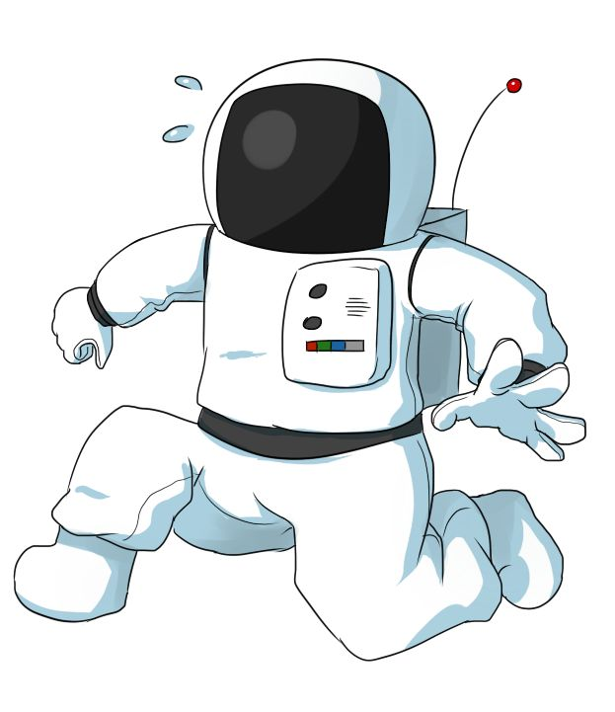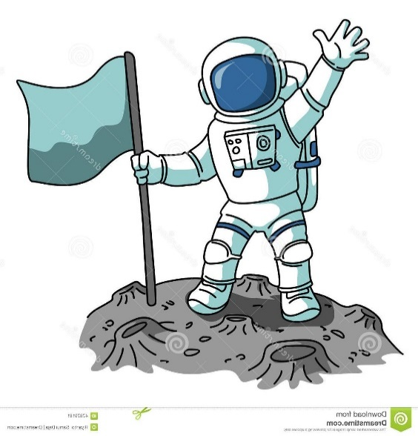
I can answer questions about astronauts in sentences
picture 1 picture 2
- Can you see two astronauts?
- Are the astronauts wearing helmets?
- Are their helmets white?
- Are the astronauts wearing boots?
- What is the astronaut in picture 1 doing?
- What is the astronaut in picture 2 doing?
- What colour are the astronauts’ spacesuits?
- What do the astronauts have on their backs?
- What are the astronauts wearing on their hands?
- .Would you like to wear a spacesuit? Give reasons for your answer.
jumping | waving | holding | flag
oxygen pack

