Bob the Man on the Moon- I can match the sentence to the picture and write my own sentence

Copy the sentence next to the correct picture and add your own sentence for each picture.
2. Make a pictorial list for Bob, of items he will need to clean up the moon. Drraw and label each item. Eg
To clean the moon Bob will need:
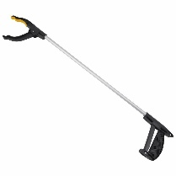Litter picker

