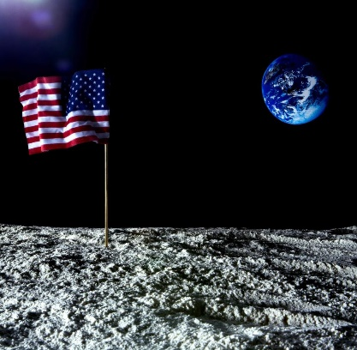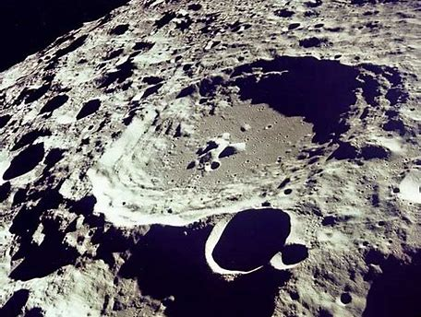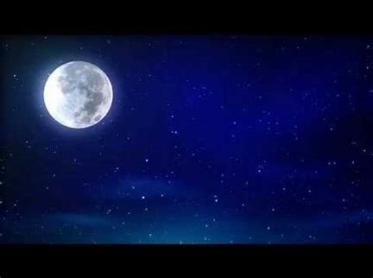
Lo-I can answer questions about the moon in sentences.
- Can you see the moon in the pictures above?
- What is the surface of the moon like?
- Who goes to the moon?
- What do you wear on the moon?
- How do you get to the moon?
- Who put the flag on the moon?
- Would you like to go to the moon? Explain your reasons.
- Draw a picture of astronauts on the moon.
Useful words and spaces to try words.
craters | rocks | dust
covered | American | astronauts
space rocket | space suit

