Week 3 Taking away
Note to parents
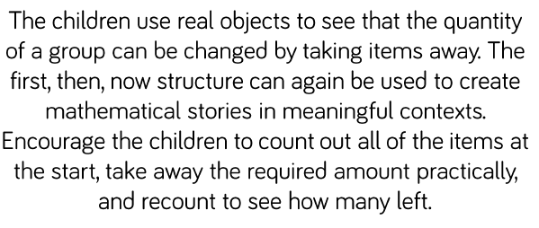
Tell simple maths stories and children can tell you the answer and show that they can represent the story on a number line to prove their answer is correct. Make sure that they take away from the larger to the smaller number, counting back.

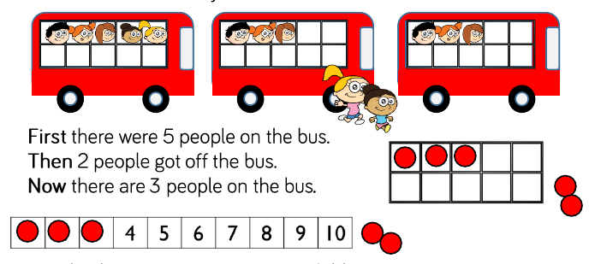
Maths activity- Hidden items
Your child should count 10 toys into a bag. Tell your child to take out a certain number. Ask them ‘How many are left? How do you know? How can you work it out?
Try and get them to think of different ways rather than just counting what is still in the bag.
They might just say the number (If they know their number bonds to 10) You can ask them to prove to you that their answer is correct. (Use the 10 frame or number line.)
If they can’t work it out you could suggest-
E.g. use the number line. We know we had 10. (Put 10 toys on the number line, one on each square.) We took 3 out (So take off the toy on 10,9, and 8) How many are left?
(They should not have to count the number that are left because they should see that it is 7 as the toys are standing on numbers 1-7.) Point this out to them if they had to count to tell you the answer.
The starting numbers to your activity can be higher to make the calculation harder. Make sure that if you are using higher numbers that you have a visual aid such as a 20 number line or 100 square for them to refer to if needed.
Play games using the number line
- Less than- What is 1 less than 5? (Alter the number, find the answer by counting back.)

- Start with a tower of blocks (10 to start, it’s up to you) Roll a dice with only 1 and 2 on the sides. Take off that number of bricks. (Can your child say how many there are without having to count each time.) Make it into a game, the first one to get to 0 is the winner.

- Pass it on-
Each child starts with a number of cubes. Preferably laid out on a number line. They roll a dice with 1,2 3 on the faces and pass the corresponding number ff cubes to the person on their left or the person they are playing with. The winner is the first person to give away all their cubes or the one that has the fewest after a given time.
Emcourage the children to say how many cubes they have left as they pass on their cubes.
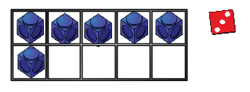
- Topmarks website-games- Chopper Squad and Helicopter Rescue are games to practise counting on and counting back on a number line.
- If you want a work sheet, try these:
https://www.numberlinelane.co.uk/worksheetlist?number=8
Others can be found on the Twinkl website if you search for ‘less’.

